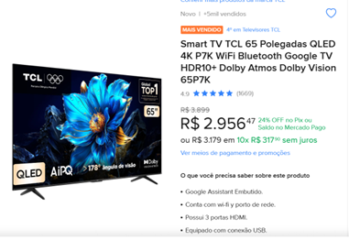
Smart TV TCL 65 Polegadas QLED 4K P7K WiFi Bluetooth Google TV HDR10+ Dolby Atmos Dolby Vision 65P7K

